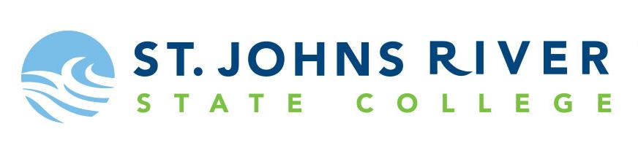
Request to Waive Florida Civic Literacy Exam Retest Waiting Period

The Florida Civic Literacy Exam (FCLE) requires a 30-day waiting period between testing attempts. Students may request to have the waiting period waived if there are circumstances that require a retest attempt before 30 days have passed. Students will be notified of the decision via their SJR State email. If approved, students may schedule an appointment for the next available testing session. If denied, students must wait 30 days from their most recent attempt before retesting.

Submit the completed form via email to testingcenter@sjrstate.edu

Name: Enter legal first and last name Student ID: Enter SJR State ID (X number)
Email: Enter your SJR State student email address Phone: Enter the best number to reach you
Date of most recent testing attempt: Enter the date of your most recent FCLE attempt
Reason for requesting waiting period to be waived:
Anticipated graduation this term ☐ Enter term and year of anticipated graduation
Other ☐ (additional information required below)
If you selected other, please provide the reason you are requesting the FCLE retest waiting period be waived. If you selected other and this area is left blank, your request will be denied.
Provide the reason you are requesting the waiting period to be waived here.

Preferred campus for retest attempt: Enter the campus where you plan to retest

I understand that I must wait 30 days before retesting or I must receive approval to waive the retest waiting period. If I am denied, I understand I must wait 30 days since my last testing attempt to retest for the FCLE.
Enter initials to confirm that you understand Date of acknowledgment

