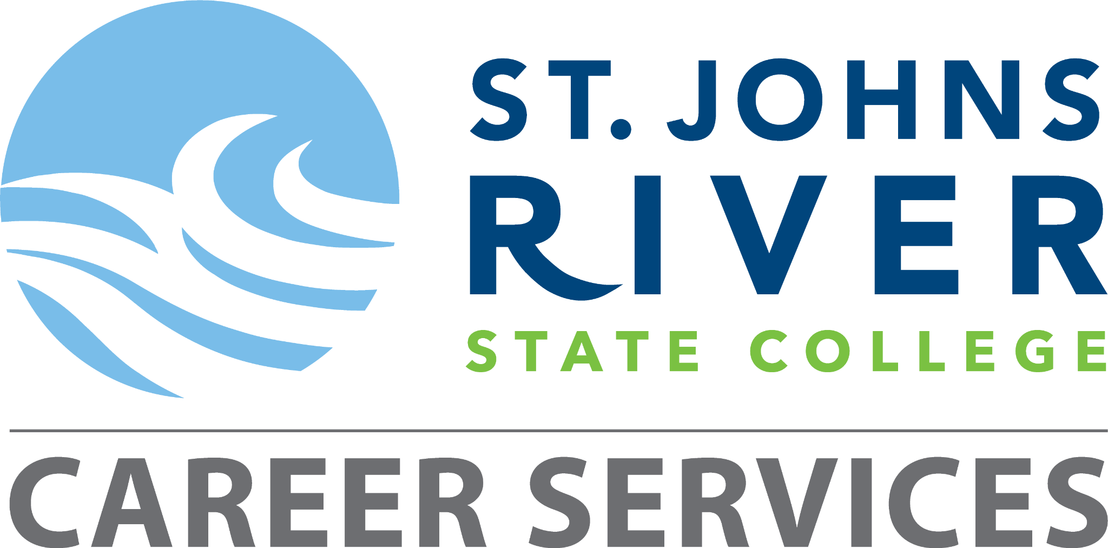

Student Career Plan: Florida Corrections Officer Academy
Complete and submit to Career Services via email: CareerServices@sjrstate.edu.
Must be completed and submitted along with your resume within 30 days of graduation to be eligible for the Money-Back Guarantee Program.
Resources can be found at sjrstate.edu/careerservices.

Student Information
Student Name | Click or tap here to enter text.
SJR State Student ID | Click or tap here to enter text.
Start Date of Program | Click or tap to enter a date.
Anticipated Graduation Date | Click or tap to enter a date.

Career Goals
- Short-Term Goal (While in Program):
Successfully complete all academy coursework, physical training, and scenario-based exercises to develop foundational law enforcement skills.
Click or tap here to enter text.______________________________________________________________________________________________________________________________________________________________________________________________________
- Mid-Term Goal (Upon Graduation):
Pass the Florida State Officer Certification Examination (SOCE) and secure employment as a corrections officer.
__Click or tap here to enter text.______________________________________________________________________________________________________________________________________________________________________________________________________

- Long-Term Goal (3–5 Years):
Pursue career advancement through specialized units (e.g., K-9, FTO, supervisory positions) and/or continue education in criminal justice or public safety administration.
_Click or tap here to enter text.______________________________________________________________________________________________________________________________________________________________________________________________________

Academic Milestones
Phase | Academic Milestone | Date Completed (✓)
Program Start | Attend academy orientation and complete intake requirements | Click or tap to enter a date.
During Program | Complete required training modules, practical scenarios, and physical training | Click or tap to enter a date.
Final Phase | Apply for and prepare for the Florida SOCE | Click or tap to enter a date.

Career Development Activities
Activity | Description | Date Completed (✓)
Resume & Cover Letter | Create and review a law enforcement-focused resume. Submit your resume via email to Career Services. | Click or tap to enter a date.
Mock Interview | Use Big Interview to practice responding to law enforcement interview scenarios. | Click or tap to enter a date.
Job Search | Register with the College Job Board. Use it and other resources to identify agency openings. Document your search. | Click or tap to enter a date.
Employer Connection | Document attendance at a criminal justice career fair, agency presentation, recruitment event, or a SJR State Career Fair. | Click or tap to enter a date.

Licensure and Employment Planning
Requirement | Description | Date Completed (✓)
Certification Exam | Register and prepare for the Florida State Officer Certification Examination (SOCE) | Click or tap to enter a date.
State Certification | Apply for Florida certification after passing the SOCE | Click or tap to enter a date.
Job Applications | Submit applications to local, county, or state corrections agencies. Keep documentation. | Click or tap to enter a date.
Follow-up | If employment is not secured within 3 months, meet with Career Services | Click or tap to enter a date.
Student Signature: ___________________________ Date of Completion: ___________
Career Services Advisor Signature: __________________________________________

