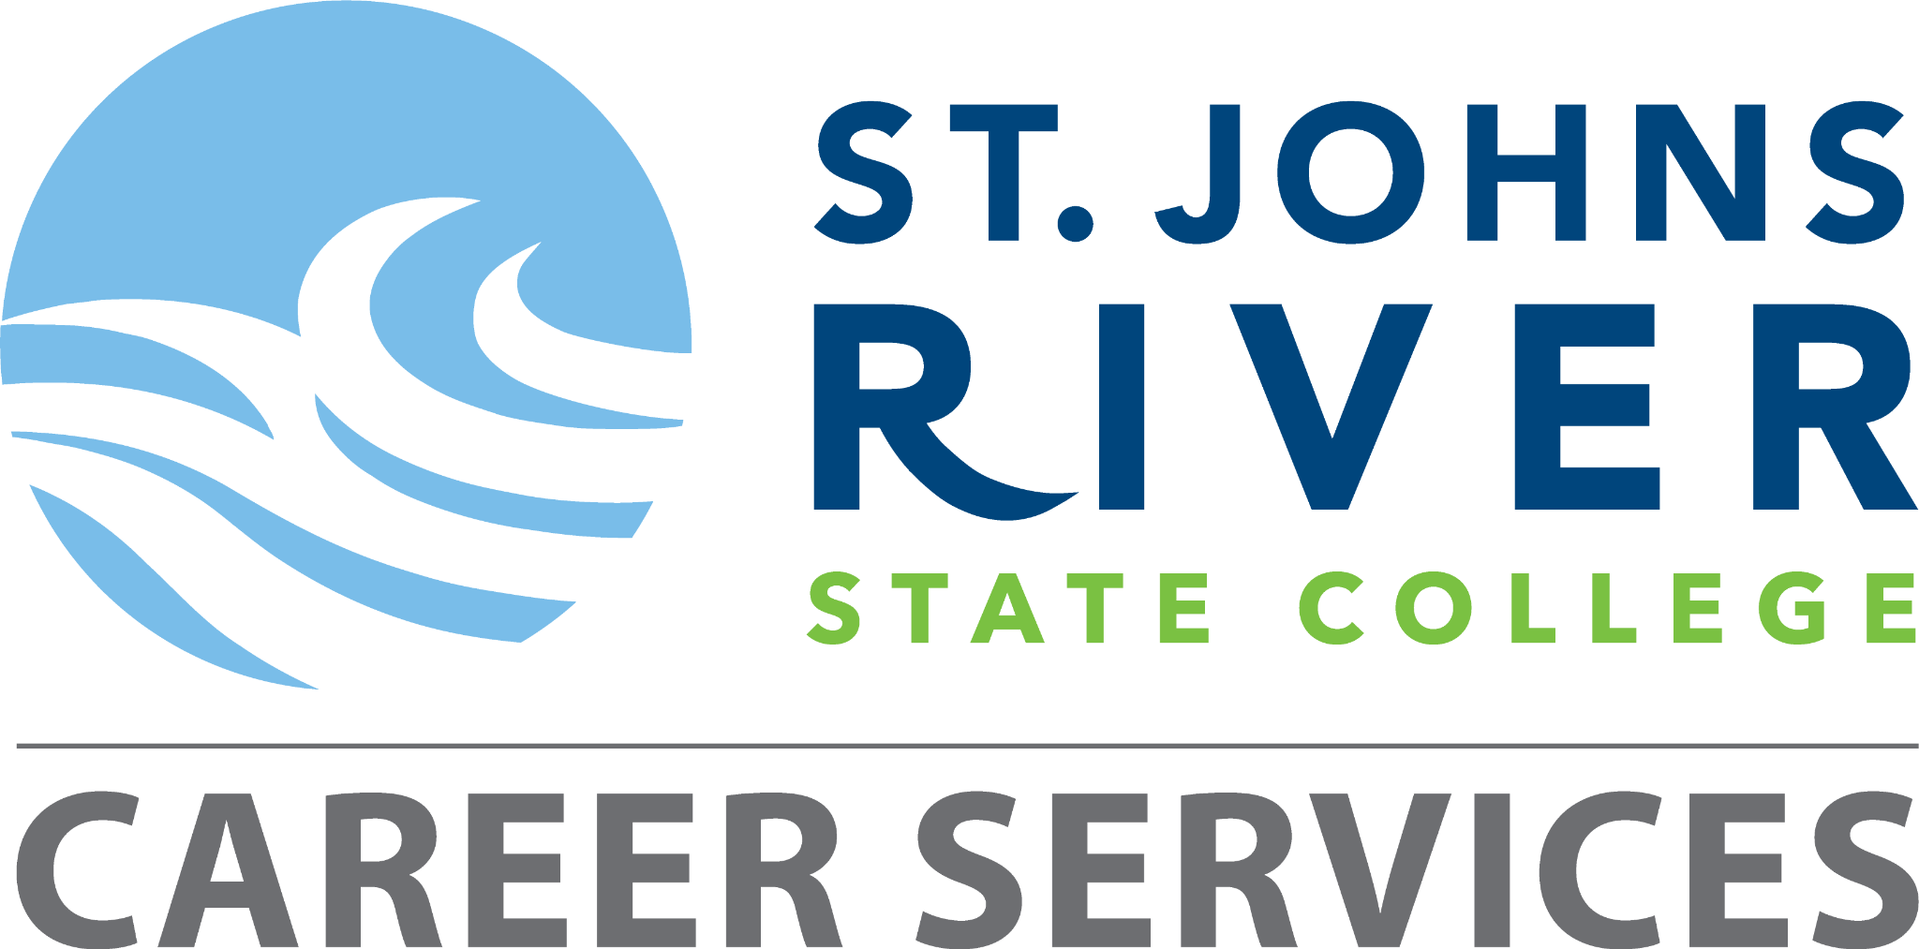

Student Career Plan: A.S. Degree in Radiologic Technology

Complete and submit to Career Services via email: CareerServices@sjrstate.edu.
Must be completed and submitted along with your resume within 30 days of graduation to be eligible for the Money-Back Guarantee Program.
Resources can be found at sjrstate.edu/careerservices

Student Information
Student Name | Click or tap here to enter text.
SJR State Student ID | Click or tap here to enter text.
Start Date of Program | Click or tap to enter a date.
Anticipated Graduation Date | Click or tap to enter a date.

Career Goals

Short-Term Goal (While in Program):

Focus on learning core respiratory care concepts and successfully complete all required clinical rotations to build hands-on experience.
Click or tap here to enter text._____________________________________________________________________________________________________________________________________________________________________________________________________

Mid-Term Goal (Upon Graduation):

Obtain a position as a Radiologic Technologist at a hospital or clinic to apply clinical skills and provide quality patient care.
Click or tap here to enter text._____________________________________________________________________________________________________________________________________________________________________________________________________

Long-Term Goal (3–5 Years):

Specialize in Click or tap here to enter text._____________________________ and/or pursue further education in Click or tap here to enter text._____________________________ to advance expertise and career opportunities.

Click or tap here to enter text._____________________________________________________________________________________________________________________________________________________________________________________________________

Academic Milestones
Semester | Academic Milestone | Date Completed (✓)
1st Semester | Attend program orientation and meet with an academic advisor | Click or tap to enter a date.
1st–2nd Semester | Begin clinical rotations and log hours | Click or tap to enter a date.
Mid-Program | Maintain the required GPA and complete the required coursework | Click or tap to enter a date.
Final Semester | Apply for Credentialing Exam | Click or tap to enter a date.

Career Development Activities
Activity | Description | Date Completed (✓)
Resume & Cover Letter | Create and review a healthcare-focused resume. Submit your resume via email to Career Services. | Click or tap to enter a date.
Mock Interview | Use Big Interview to practice interview skills. | Click or tap to enter a date.
Job Search | Register with the College Job Board. Use the job board along with other resources for job search.  Document your job search. | Click or tap to enter a date.
Employer Connection | Document attendance at the Allied Health Career Day or another SJR State Career Fair. | Click or tap to enter a date.

Licensure and Employment Planning
Requirement | Description | Date Completed (✓)
Credentialing | Register and prepare for R.T. exams (ARRT) | Click or tap to enter a date.
State Licensure | Apply for Florida licensure after credentialing | Click or tap to enter a date.
Job Applications | Submit applications to hospitals/clinics | Click or tap to enter a date.
Follow-up | If you have not secured a position within 3 months of graduation, schedule a meeting with Career Services | Click or tap to enter a date.
Student Signature: ___________________________
Career Services Advisor Signature: ___________________________
Date of Completion: ___________________________

